* **Self-invoke** function is a type of functions that calls itself automatically without explicitly call it as normal functions.
* Self-invoked function can be used to in some situations in which you are not waiting for an input from the user such as connecting to server after loading the page. Loading specific theme for this page.

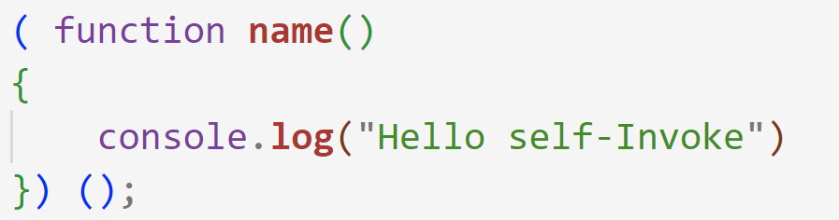

* We can create a Self-invoke function without a name which is called **anonymous** Self-invoke function.

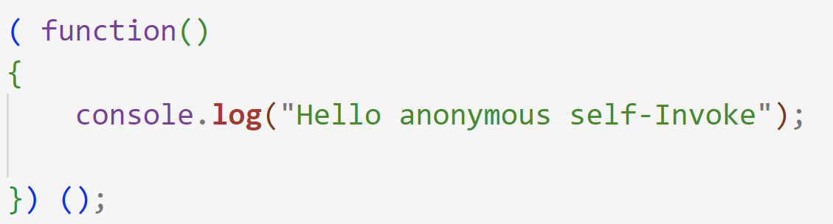

* Self-invoked function can take default parameters as num=3.

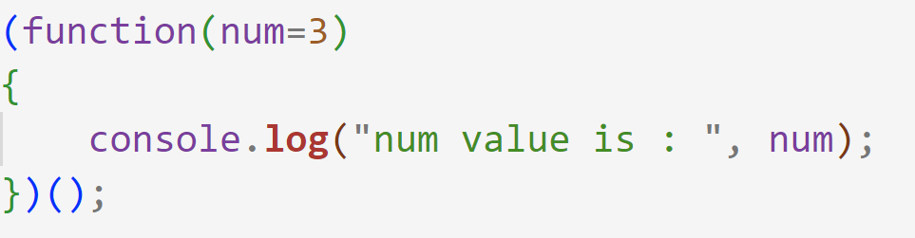

* We can call the function with any other parameter as below, but it will be called twice one for default value, and one for new parameters.

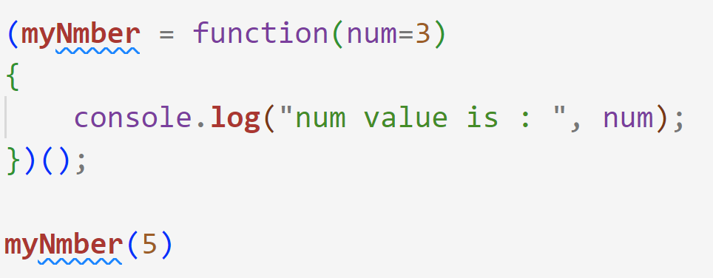

Output:

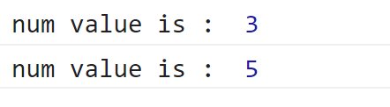

* We can solve it by passing the new parameter in the parenthesis

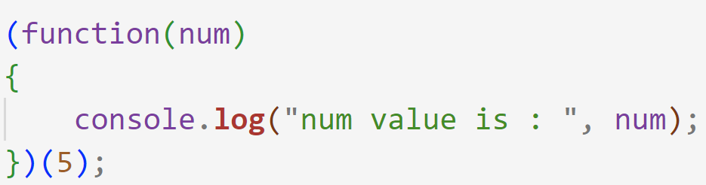

Output :



* You can return a value from the self-invoked function by setting the return statement to be in a function.

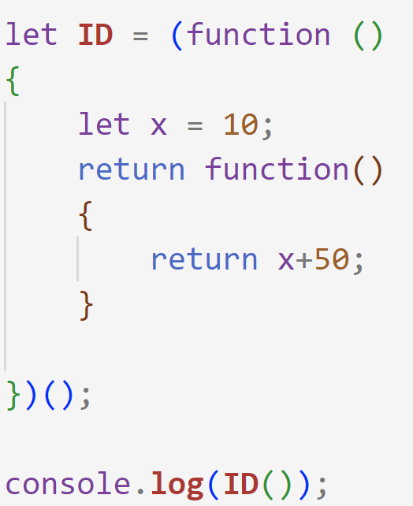

Output is : 60